3.8 View Flood Conditions by Sensor Stations
Function trigger:
- Navigation path: Map Screen (Mapbox) → Tap a Sensor Station Marker
- Timing Frequency: On demand.
Function description:
- Actors/Roles: Citizen, Monitor and Admin (Authenticated users)
- Purpose: Displays flood conditions and latest readings collected from sensor stations.
- Interface:
  - Map View (Mapbox): Displays sensor station markers.
  - Station Markers: Marker color reflects flood severity, consistent with the Flood Severity legend.
  - Flood Severity Legend: Shows severity levels (Safe / Caution / Warning / Critical) with corresponding colors.
  - Flood Detail Popup Card (on marker tap): Shows a quick overview of the selected station and its latest reading.
  - “View detail” button: Navigates to another use case (Flood History / analytics) for station history & predictions (not detailed in 3.8)
Data processing:
- Actors/Roles: Citizen, Monitor and Admin (Authenticated users)
- If provided, the system applies filters:
  - Status filter (Stations.Status)
  - Map bounds filter (min/max lat/lng) to return only stations in the current viewport.
- The system queries SensorReadings and gets the latest reading per station (by MeasuredAt).
- For each station, the system derives flood severity from the latest water level and maps it to a severity level + marker color (aligned with the Flood Severity legend). If no reading exists, severity is No data/Unknown
- The system returns a GeoJSON FeatureCollection: Each station is a Point feature with properties needed for:
  - marker rendering (severity, markerColor, alertLevel)
  - popup flood detail card (station info + latest reading + updated time).
Screen layout:
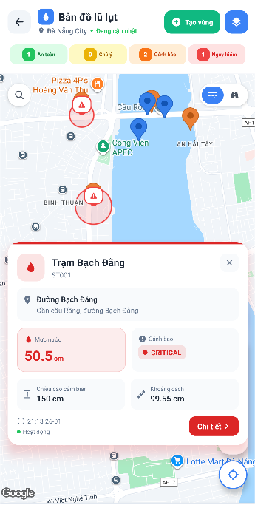
Figure 20.1 - View Flood Conditions by Sensor Stations
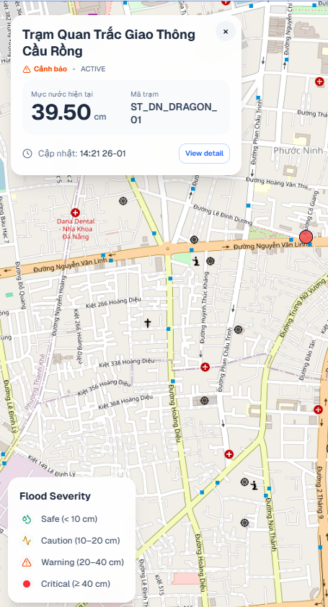
Figure 20.2 - View Flood Conditions by Sensor Stations

Function details:
- Data:
  - Geometry: Point [longitude, latitude]
  - Station info: stationId, stationCode, stationName, locationDesc, roadName
  - Latest reading: waterLevel, distance, sensorHeight, unit, measuredAt
  - Flood condition: severity, severityLevel
  - Station status: stationStatus, lastSeenAt
  - Map styling: markerColor, alertLevel
- Validation:
  - Latitude (MinLat, MaxLat): must be within [-90, 90]
  - Longitude (MinLng, MaxLng): must be within [-180, 180]
  - Status : must be one of active, offline, maintenance
- Business rules: Any authenticated user can view flood conditions by sensor stations.
- Normal case:
  - User opens the Map and sees station markers colored by flood severity.
  - User taps a marker → system shows the Flood Detail Popup Card with station overview + latest reading time/value.
  - User taps “View detail” → navigates to Flood History / analytics screen(except Citizen).
- Abnormal case:
  - Station has no latest reading → marker/popup displays No data/Unknown state.
  - Invalid bounds/status filter → system returns a validation error and keeps the map in the current state.

